Software engineering for big data analaysis

CSA-1035

EXP NO:- 12

1. Draw a Activity diagram for Online Voting System for a software platform that allows groups to securely conduct votes and elections using CASE tools. The voters should be able to register via some proper authority. Construct a system in which the voters should see the list of candidates present in his constituency. A voter should be able to cast his vote to a candidate and that voter should cast only 1 vote at a time Draw an Activity diagram for Library Management System using CASE tools.

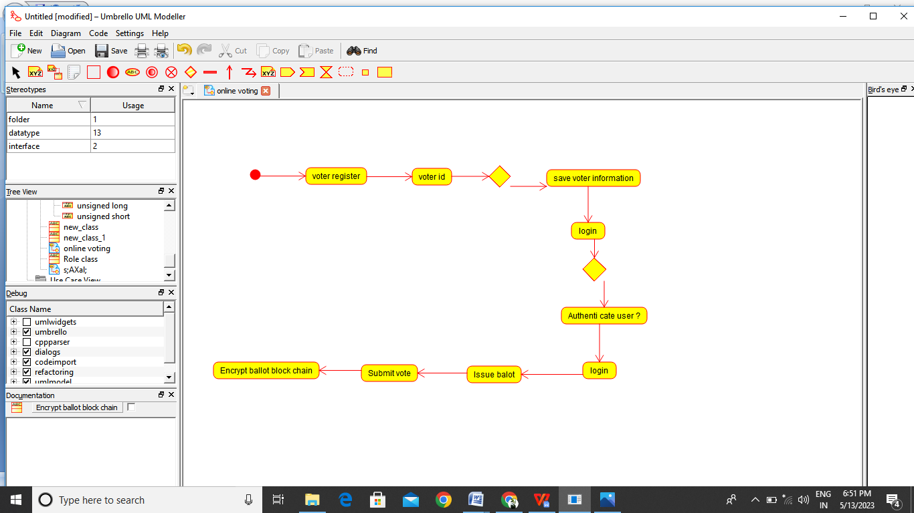

RESULT:-

Thus the Activity Daigrame for online voting is drawn and verified successfully